Class Time:
Names:

The Central Limit Theorem: Central Limit Theorem Lab I
Student Learning Outcome:
- The student will examine properties of the Central Limit Theorem.
Note: This lab works best when sampling from several classes and combining data.
Collect the Data
- Count the change in your pocket. (Do not include bills.)
- Randomly survey 30 classmates. Record the values of the change.

- Construct a histogram. Make 5 - 6 intervals. Sketch the graph using a ruler and pencil. Scale the axes.

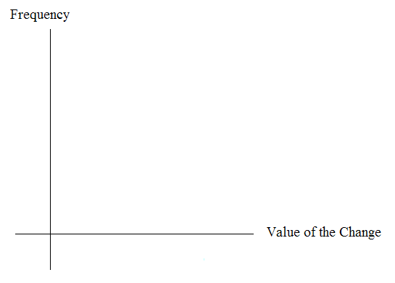
4. Calculate the following: a. = _________ b. s = __________ ( n = 1; surveying one person at a time)
5. Draw a smooth curve through the tops of the bars of the histogram. Use 1 – 2 complete sentences to describe the general shape of the curve.

Collecting Averages of Pairs
- Repeat steps 1 - 5 of “Collect the Data” with one exception. Instead of recording the change of 30 classmates, record the average change of 30 pairs.
- Randomly survey 30 pairs of classmates. Record the values of the average of their change.

- Construct a histogram. Scale the axes using the same scaling you did previously. Sketch the graph using a ruler and a pencil.
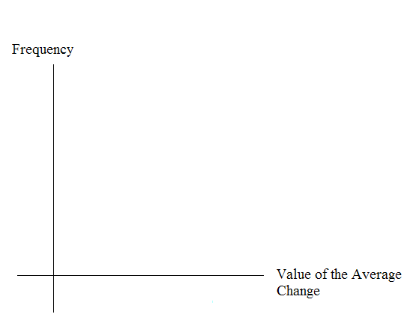
4. Calculate the following: a. = _________ b. s = __________ (n = 2; surveying two people at a time)
5. Draw a smooth curve through the tops of the bars of the histogram. Use 1 – 2 complete sentences to describe the general shape of the curve.

Collecting Averages of Groups of Five
- Repeat steps 1 – 5 of “Collect the Data” with one exception. Instead of recording the change of 30 classmates, record the average change of 30 groups of 5.
- Randomly survey 30 groups of 5 classmates. Record the values of the change.
3. Construct a histogram. Scale the axes using the same scaling you did previously. Sketch the graph using a ruler and a pencil.

4. Calculate the following: a. = _________ b. s = __________ (n = 5 ; surveying 5 people at a time)
5. Draw a smooth curve through the tops of the bars of the histogram. Use 1 – 2 complete sentences to describe the general shape of the curve.

Discussion Questions
- As n changed, why did the shape of the distribution of the data change? Use 1 – 2 complete sentences to explain what happened.

- In “Collect the Data”, what was the approximate distribution of the data?
~ _________________________

- In “Collecting Averages of Groups of Five”, what was the approximate distribution of the averages?
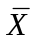~ ___________________________

- In 1 – 2 complete sentences, explain any differences in your answers to 2 and 3.

